Paulton Infant School: The Recovery Curriculum

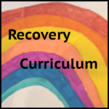

What is a recovery curriculum?
This recovery framework is based upon our research on the work by Barry Carpenter and Evidence for Learning team, which sets out the importance of recognising the changes, trauma and loss children have experienced throughout the Covid- 19 pandemic. We also recognise that many children will have had a positive experience, forming positive attachments with their families and accessing a broad range of activities and curriculum.
Successful transition back into school is key in enabling pupils to become confident in learning again. The way we do this is to acknowledge and accept the losses we have all been through during the pandemic.
Bedwetting
Anger/ tantrums
Irregualr mealtimes/ Lack of food/nutrition
Irregular bedtimes/ Loss of sleep
Loss of routine
headaches
Grief
Loss of structure
Lack of Play opportunities
Loss of friendship
Lack of learning
Loneliness/withdrawal
Loss of opportunity
Loss of trusted friends/ trusted adults/ social interaction
Low resilience
Loss of concentration
Loss of freedom
Lack of milestones/ goals

Hearing anxiety and worries of adults/ the news
Self-harm
Insecurity/ worry
Fear

The Recovery Experience
This curriculum allows our pupils to ‘learn how to learn’ in a school setting once again by ‘re-engaging in learning’ through play, exercise and structured activities. Our children will be given the time and space they individually require to transition successfully back into school.

The principles underpinning our recovery curriculum are:
- Equity (putting more in to enable all children to have an equal opportunity)
- Resilience
- Flexibility
Our aims of the curriculum are:
- To build trust and relationships
- To recap on how to socially interact with adults and peers
- To begin to follow a structure and routine within a school setting
- To learn how to co-regulate or self- regulate emotions and behaviours
- To learn how to manage emotions
- To engage in learning by referring to Gem Power
- To re-establish the smaller building blocks of learning through clear modelling and initially short, highly-structured activities
- To systematically close any gaps in learning following robust assessments in phonics, reading, writing and maths
- To build physical well-being as a support for developing mental well-being
- To build up their stamina for learning
The curriculum will follow a thematic cross curricular approach, which provides a low demand curriculum with structured, motivating activities. All staff will use the time to observe and note what engages them as individuals and having the flexibility to plan future experiences based on this. In addition to planned opportunities for learning, staff will look for opportunities to support and develop incidental learning in all situations. We know that when children are engaged their learning is deeper and more meaningful.

“Engagement is….a journey which connects a child and their environment….to enable learning and achievement” Carpenter et al. 2011

Recovery Pathway of support
The recovery curriculum fits well within our Curriculum approach, established across the school.
The recovery curriculum is based on the work of Barry Carpenter and the Evidence for Learning team: “A Recovery Curriculum: Loss and Life for our children and schools post pandemic”
There will be a four phase approach to the curriculum.
Staff will carefully assess individual children and decide the appropriate approach in discussion with their families.
Focus Recovery
(A personalised , and equitable needs led approach)

Holistic Approach
Re-Connection
(Themed based – Fun/ engaging and provoking a positive response)
Assessment to identify needs
Opportunity to reflect
Deep Recovery (longer period of recovery and specialist support)

At the heart of all phases is Social, Emotional and Mental Health and Wellbeing. Appropriate mental health support and interventions will depend on what phase each individual is at when they return to school. We recognise that many children will be keen and ready to continue with their academic learning.

Universal offer includes a thematic cross curricular approach to learning that supports children to reconnect with their environment, re-establish relationships, share experiences of lockdown in a safe and supportive environment and re-discover a love of learning through an inclusive, play based curriculum which fosters creativity and enjoyment.
Parents will be supported to contact school to discuss their anxieties of school re-opening and staff will work hard to allay fears and instil confidence in the parent/carers decisions.
Concerns raised from questions 5,6,7,8,11,12,13,14 indicate a Universal approach
Feedback from questionnaires will help determine what support is needed.
Focused recovery may include:
- Support from the Thrive to run 1-1/ small group sessions
- Thrive practitioner 1-1/ small group session. (if budget allows)
- Parental support via PSA
1.Has anyone been ill?
2. Have they suffered bereavement?
3. What was the impact of Covid?
4. Have parents/carers sought help from other agencies/professionals? if so who and why?
5 & 6. Have they interacted with anyone outside of the family home?
7. How have parents/carers coped? Has there been a routine/structure in place?
8. Have they managed to engage in curriculum tasks?
9,10 &11. Has there been a change in emotional and social presentation? What and reasons?
12 & 13. How do parents/carers feel about their child’s return to school?
14 & 15. How does the child feel about returning to school?
Concerns raised from questions 1,2,3,4,7,9,10 may indicate a more focused approach

Deep recovery may include specialist support such as:
- Music/ Play or Art Therapy /B&A referral for therapeutic support
- Referral to children’s centre for under 5s (All Reception children at age 4 are entitled to this).
- CAMHS referral
- Bereavement support (Winston’s Wish/Thrive activities/Cruse stories- )
- EP referral
Concerns raised from questions 1,2,3,4,7,9,10 indicate a deep recovery.

We need to remember that:
“School is no longer the safe, constant place we thought it was. We must be ready to understand, to reframe their perception, and show that we are trustworthy (Barry Carpenter & Matthew Carpenter, 2020).

Our aim is for the recovery curriculum to be for the first term for KS1 when we return to school. Some children may need a different time scale but we will personalise that experience as necessary. We will review this after each term.
Communication with parents is going to be vital during this first term. In EYFS this will be carried out by Evidence Me. In KS1, we will use School Comms using the email addresses set up during Lockdown. We are aware that some families may really struggle with sending their children to school due to anxieties around Coronavirus. We will write a social story for all families starting school in September to explain key expectations around hygiene/safety practices in school.

Curriculum drivers

We learn through building strong relationships and social skills of all learners where education is a fun, challenging experience. We do not set limits on learning and apply a growth mindset to everything we do. Our staff work extremely hard to create engaging activities to motivate us all to want to learn.

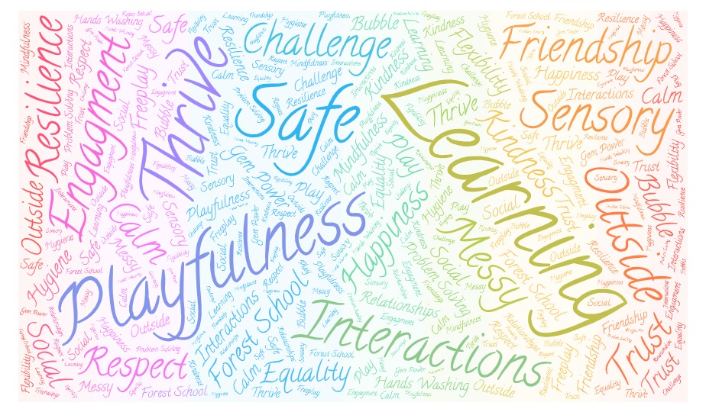

What, How and Why
“Now is the time to return to more humane approaches concerned with the fundamental wellbeing and secure positive development of the child. Without this there will be no results that have true meaning and deep personal value to the child in terms of preparation for adulthood.”
Barry and Matthew Carpenter, 2020
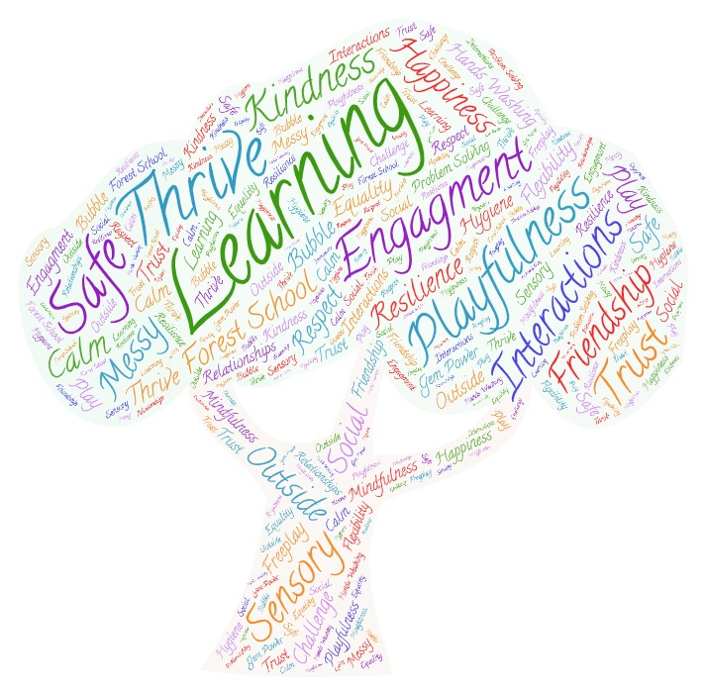

Lever | What? | How? | Why? | How do we measure impact?
Rebuilding Relationships  LEVER 1  RELATIONSHIPS  “We can’t expect our children to return joyfully, and many of the relationships that were thriving, may need to be invested in and restored”  Barry and Matthew Carpenter, 2020 | Making contact with children and families.  Carefully planned relationships building activities upon return.  Time to ‘be’  Time to play (natural social interactions)  Jigsaw Jack/Circle Time/PSHE/ Scavenger hunts, Tiddler stories – getting to know new room/planned creative sessions/ Singing  Sunshine circles/Theraplay  S & L barrier games | Website, emails, phone calls weekly  Zoom meetings to support end of this academic year  Questionnaires  PUPILS TO REMAIN IN THE SAME CLASSES AS LAST YEAR (new Teacher)  Focus in Term 1 to build on relationships  Free play opportunities and planned physical exercise across the school, Forest School, managed risky play  Thrive activities  Zen den | Children and families begin to understand we are still here and haven’t abandoned them. They begin to accept school is still here and we will help them get back to school in the safest possible way.  Trust begins to be re-established.  Listen to parents as will enable us to understand what support is required. | Engagement of families.  Interaction of children in school setting  % children returning to school

Lever | What? | How? | Why? | How do we measure impact?
LEVER 2  COMMUNITY  “We need to listen to what has happened, and understand the needs of our community and engage them in the transitioning of learning back into school”  Barry and Matthew Carpenter, 2020 | Questionnaire for staff and families  Sharing social stories with our community to support understanding of what school will look like  http://www.companythree.co.uk/#coronavirus-time-capsule  https://booksbeyondwords.co.uk/downloads-shop/beating-the-virus | Feedback from questionnaires,  Observation.  Discussion with Parents/ Families.  Information from outside agencies and information shared with staff during lockdown. | Appropriate phase for individual children. Signpost appropriate intervention and support. | Observations  Discussions with all stakeholders  Ongoing working phase document

Lever | What? | How? | Why? | How do we measure impact?
5 Losses:  LEVER 3  TRANSPARENT CURRICULUM  “All will feel like they have lost time in learning and we must show them that we are addressing these gaps to heal the sense of loss Barry and Matthew Carpenter, 2020 | Teachers/ Staff to focus on 5 losses  Loss of routine  Loss of structure  Loss of friendship  Loss of opportunity  Loss of freedom | What do these mean for each of children?  What does it look like?  How does it present in the child? | Inform planning and interventions requires to ensure a successful transition back to school and to learning.  Developmentally appropriate strategies and interventions. | Observations.  Discussions with staff and parents.  Use of assessment sheets (tick sheets )/intervention plans to target gaps in knowledge and understanding – precision teaching:  - S&L  - Phonics  - Reading  - Writing  - Maths

Lever | What? | How? | Why? | How do we measure impact?
Inquiry based learning  LEVER 4  METACOGNITION  “Students will have been learning in different ways. It is vital that we make the skills for learning in a school environment explicit to our students to reskill and rebuild their confidence as learners.  Barry and Matthew Carpenter, 2020 | Revisit/Reteach Gem Powers methodically  Staff CPD – WalkThrus Tom Sherrington  Mentoring of early and mid-career teachers  Ensure classrooms offer calm/quiet learning spaces so that all children can access learning  Themed based topic that engages and motivates all children.  Play and fun practical activities. | Time to rebuild confidence, self-esteem, resilience, how to interact  Time to observe and be reflective about teaching- coaching (staff)  Discovering what really engages each individual. Time to play, build trust and relationships.  Time to learn how to be…. | Re-engagement of learners.  Co or self- regulation  Secure  Behaviours managed safely  Relationships rebuilt  Trust  Wellbeing of all considered and supported.  Staff confident that they understand the engagement of each child. | Targets for Gem Powers – e.g children attach face/name to a Power when they have successfully demonstrated this  Behaviour Policy is monitored by Key Stage Leaders weekly and fed back to SLT.

Lever | What? | How? | Why? | How do we measure impact?
LEVER 5 SPACE  “To be, to rediscover self and to find their voice on learning. It is only natural that we all work at an incredible pace to make sure this group of learners are not disadvantaged against their peers, providing opportunity and exploration alongside the intensity of our expectations” Barry and Matthew Carpenter, 2020 | Plan do review each week  Staff and team meetings  Well- being activities for staff  Plan do review (Use of LA Graduated Response document)  Good understanding of how each child develops. Listen to staff and how they are learning and understanding.  Regular communication with parents  Questionaire with staff and parents at the end of term to reflect on the impact of our recovery curriculum | Regular checks with staff that they are all okay – use of line management plan set up during Lockdown.  Monitoring to ensure all children’s needs are being met.  Peer to peer coaching  Effective communication with staff, parents, governors and children if appropriate | Everyone is given the time and space to recover and reengage.  Celebration of successes.  Everyone feels valued and understood  Everyone feels supported  Everyone children, staff and parents are ready to move forward and be effective learners. All individuals SEMH needs are being addressed and interventions are successful. | Readiness to progress on the appropriate individual pathway with highly skilled, reflective and confident staff

“Our quest, our mission as educators, should be the journey with a child through a process of reengagement, which leads them back to their rightful status as a fully engaged, authentic learner” Barry and Matthew Carpenter, 2020.

“Now is the time to address the damage of loss and trauma, so that it does not rob our children of their lifelong opportunities. Now is the time to ensure that we restore mental wealth in our children, so that their aspirations for their future, can be a vision that becomes, one day, a reality” Barry and Matthew Carpenter, 2020.

Acknowledgements
The Mendip School
Jenny Short
NAHT
https://www.schudio.tv/courses/preparing-autistic-send-children-for-going-back-to-school
https://www.goodlifedeathgrief.org.uk/content/resources/Whole_School_Approach_to_LossAndBereavement).pdf
https://www.evidenceforlearning.net/wp-content/uploads/2020/04/Recovery-Curriculum-Loss-and-Life-for-our-children-and-schools-post-pandemic-3.pdf
https://engagement4learning.com/
Teaching walkThrus – 5 steps to coaching by Tom Sherrington & Oliver Caviglioli

Recovery Curriculum Framework

Thrive targets – See Mrs Blacker/Mrs Perry for additional support
Being  This child's developmental task is to be confident and appropriately trusting.  To be receptive to new experiences and relationships.  To be aware of needs, able to signal distress and ask for help. | Thinking  This child's developmental task is to be able to name, express and handle feelings.  To understand rules and cause and effect.  To think for themselves and can say ‘no’ with meaning.
Doing  This child's developmental task is to be curious, creative and to take initiative.  To be active and easily stimulated.  To enjoy investigating and getting involved. | Power and Identity  This child's developmental task is to have a positive sense of self and individual identity.  To adapt to different roles and relationships.  To understand consequences and contexts.

Being- Doing- Thinking- Power and Identity-

Recovery Curriculum Framework
Mental Health and Wellbeing targets

I feel included
I feel confident to speak in class
I feel confident to speak to my teachers if I worry about something
I know who my safe person is and I feel confident sharing my problems with that person
There are people in school who like me
I don’t have many worries/ or I can use strategies to help me manage my worries
I sleep well / I get enough sleep
I sleep through the night
I feel safe at school
I use strategies to help myself when I feel angry
I am able to manage my anger without losing my temper, hurting others, breaking things
I have tools I can use to manage anxiety
I know what my positive character traits are and I celebrate them
I can identify things I am grateful for
I understand what kindness is and how to show kindness
I have friends in school who play with me
I can work out my problems
I do things at home that make a difference (i.e. make things better)
At school, I decide things like class activities or rules
I do things at school that make a difference (i.e. make things better)
There are many things that I do well (I’m aware of what they are)
I feel bad when someone gets their feelings hurt
I try to understand what other people feel
When I need help, I find someone to talk to
I know where to go for help when I have a problem
I try to work out problems by talking about them
I have goals and plans for the future
I think I will be successful when I grow up
I engage in daily physical activity that makes me feel good
I have a hobby/interest outside of school that I enjoy engaging in
I can use a range of tools that help me relax e.g. yoga, mindfulness, deep breathing, listening to music, physical activity, etc
I have a healthy diet (balanced and acceptable in terms of sensory needs)
I have a range of strategies I can choose from to meet my sensory needs
I can recognise when I need to proactively do something to meet my sensory needs
I know when I need a break, I can ask for it, and I have a safe space I can go to

I have a positive relationship with the adults in my class
I am comfortable with my appearance

I can contribute in a positive way to my class community/school community

I am aware of the different groups I belong to

I can recognise a range of different feelings within myself and name them
I can recognise a range of different feelings in others

I can talk about my feelings

I have personal goals I want to achieve and I have a plan as to how I’m going to reach them

Ideas For Each Principle Of Curriculum

Relationships | See extensive list of relationship and trust building games saved in Contingency planning- Recovery Curriculum  Communication:  Making contact with children and families via emails, zoom, telephone calls, questionnaires  Carefully planned relationships building activities upon return.  Zoom assemblies/opportunities  Useful stories:  So Much  The Large Family  The Colour Monster  Ruby’s Worry  The book with no words  Tanka Tanka Skunk  CBBC Nursery Rhymes  THRIVE (See also SEAL materials)  Time to ‘be’ & Time to play (natural social interactions)  Pass the smile (or something else)  Feather Painting  Sunshine circles/Theraplay  Jigsaw Jack/Circle Time/PSHE/ Scavenger hunts, Tiddler stories – getting to know new room/planned creative sessions/ Singing  Mindfulness  Relax Kids  Outdoor:  Waterplay  Sensory Play  PE:  Use of Real PE Resources which include social and emotional learning  Cosmic Kids  Zen Den  GoNoodle  Jumpstart Johnny  Brain Gym  S & L:  barrier games  Photocopier Game  Thinkers Keys  Explorify  Pobble365  Call & Response  Turn Taking Games  Drama – Freeze frames, hot seating, helicopter stories  Bubble Buddy:  Messages, Pictures, letters, post cards, video clips to old teachers/friends
Community | Make a flower out of tissue paper and pipe cleaner to give to key working staff thanking them.  Make a bucket list of things you want to do once lockdown is over.  Write a letter to the staff in the local shop thanking them.  What have the children missed about Paulton Infant School; talk about how it made them feel, how they feel to be back, what they are looking forward to  Watch the staff videos on Facebook– how did it make you feel? Did other members of your family see it who do not live in your house?  Draw or write how you managed to stay connected to family and friends i.e. Zoom, phone calls, letters, video story time with grandparents  Make a time capsule of all the activities you have enjoyed doing while in lockdown – teacher to put all in a shoe box to bury.  Draw around your hand and in each finger write / draw 5 ways you have helped your community since lockdown eg. Clapped for NHS, gave to a food bank, helped around house, food shopping to grandparents. Make time to discuss what children may have learnt outside the curriculum. Turn this into a drama guessing game. Draw out and create a display
Transparent Curriculum | Share timetable with them, where appropriate. Be honest about learning outcomes. Reassure them, there is nothing to worry about if they have forgotten things.
Metacognition | Fun quiz – e.g. what are the Gem Powers? Tell me one thing you have used each power. for Name 3 things you can do if you are stuck? What can you look at to see what you will be doing different stages of the day? (visual timetable)  Draw around different classroom equipment in chalk on the playground, can children match the items?  Listening games- make a sound with a selection of objects, children to guess what it is.
Space | Dance! Be Creative!

Appendix 2
Resources
Saved in Shared Docs/@whole School Curriculum/2020/21 Recovery Curriculum
Loss and Bereavement
Recommended reading list for Loss- Thrive
List of Bereavement Ideas
Relationships and Trust
Thrive ideas- home activities
Relationship and trust building- list of activities
General Mental Health Resources
Mentally Healthy School Coronavirus Toolkits
https://www.mentallyhealthyschools.org.uk/resources/
Sharie Coombes books- Letting Go in particular
Whole class brain developmental lessons plans/Growth Mindset
Whole Class resilience lessons plans
Each pupil make a Happiness drawer/ class happiness box!
https://healthyemotionallives.co.uk/ - a lot of really good videos and resources for specific age groups about being “emotionally healthy”

Exploring Narratives
Books Beyond Words: Beating The Virus
https://booksbeyondwords.co.uk/downloads-shop/beating-the-virus
Make a time capsule based on experiences during the lockdown- Drama based
http://www.companythree.co.uk/#coronavirus-time-capsule

Appendix 3
 | 840-9 | 9-930 | 930-1030 | 1030-11 | 11-1115 | 1115-1220 | 1220-1 | 1-130 | 130-230 | 230-3
Monday | Arrival | Morning Activities  Table 1- Uno  Table 2- Colouring  Table 3- Jigsaws  BB- 1-1 chat | English  Relationship building games | Snack  Breaktime outside 1030-1045 | Reading  Class book | Discovery Time  1- Lego challenges  2- Water challenges  3- Drawing challenges  Allow for play | Lunch and playtime outside | Mindfulness | Science  Experiment see ideas in recovery curriculum folder | Reflection + Chapter from Class Book
Tuesday | Arrival | Morning Activities  Option 1- Handwriting  Option 2- Maths problems  Option 3- colouring | Maths  Group Games outside  e.g. Floor snakes and ladders | Snack  Breaktime outside 1030-1045 | Reading  Quiet reading | English  Skills based  Skills you are confident pupils already have and can successfully used. | Lunch and playtime outside | Cosmic Yoga | Art | Reflection + chapter from Class book
Wednesday | Arrival | Morning Activities | English  Drama based  Begin with confidence building activities | Snack  Breaktime outside 1030-1045 | Reading  Class book | Topic  Based on interests- each session a different pupil chooses topic and research together + creative activity. | Lunch and playtime outside | Mindfulness | Music  Each pupil chooses a different song | Reflection + chapter from Class book
Thursday | Arrival | Morning Activities | Virtual Assembly | Snack  Breaktime outside 1030-1045 | Reading  Quiet reading | Topic  Based on interests- each session a different pupil chooses topic and research together + creative activity. | Lunch and playtime outside | 30- minute cartoon | Discovery Time  Inquiry activities based on theme  Allow for play | Reflection + chapter from Class book
Friday | Arrival | Morning Activities | Maths  Board Games | Snack  Breaktime outside 1030-1045 | Reading  Class book | Weekly Reflection  Lunch early at 1145 | PPA | PPA | PPA | PPA
Suggested daily timetable (Please note –all classes will have their own individual timetable)

